PSA

Assignment 4

Name: Parth Kataria

NUID: 002964611

Part 1 Implementation

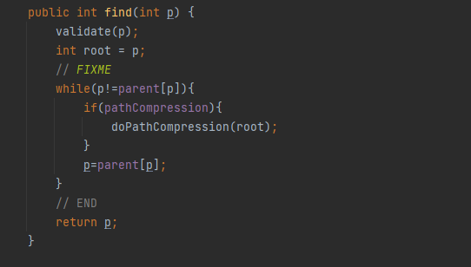

Part 2 Unit test

Part 3 Result

Part 4 Conclusion

From the above results we can conclude that

M = ½(n\*ln(n))

Part 5 files



